// Hibernate standalone and web Application

PROGRAM CODE
<!DOCTYPE html>
<html>
<head>
<title>Cake Shop</title>
</head>
<body>

<h1>Welcome to Cake Shop</h1>

<a href="cakes">View Cakes</a>

</body>
</html>

package com.example;

import javax.persistence.*;

@Entity
@Table(name = "cake_db")
public class Cake {

@Id
@GeneratedValue(strategy = GenerationType.IDENTITY)
private int id;

private String name;
private double price;

public String getName() {
return name;
}

public void setName(String name) {
this.name = name;
}

public double getPrice() {
return price;
}

public void setPrice(double price) {
this.price = price;
}
}

package com.example;

import java.io.IOException;
import java.io.PrintWriter;

import javax.servlet.ServletException;
import javax.servlet.annotation.WebServlet;
import javax.servlet.http.*;

import org.hibernate.Session;
import org.hibernate.SessionFactory;
import org.hibernate.cfg.Configuration;

@WebServlet("/cakes")
public class CakeServlet extends HttpServlet {

protected void doGet(HttpServletRequest request, HttpServletResponse response)
throws ServletException, IOException {

response.setContentType("text/html");
PrintWriter out = response.getWriter();

SessionFactory factory = new Configuration()
.configure("hibernate.cfg.xml")
.addAnnotatedClass(Cake.class)
.buildSessionFactory();

Session session = factory.openSession();

// Fetch data
java.util.List<Cake> list = session.createQuery("from Cake", Cake.class).list();

// HTML response
out.println("<html><body>");
out.println("<h2>Cake List</h2>");

for (Cake c : list) {
out.println("<p>" + c.getName() + " - ₹" + c.getPrice() + "</p>");
}

out.println("</body></html>");

session.close();
factory.close();
}
}

Hibernate.cfg.XML
<!DOCTYPE hibernate-configuration PUBLIC
"-//Hibernate/Hibernate Configuration DTD 3.0//EN"
"http://hibernate.sourceforge.net/hibernate-configuration-3.0.dtd">

<hibernate-configuration>
<session-factory>

<property name="hibernate.connection.driver_class">
com.mysql.cj.jdbc.Driver
</property>

<property name="hibernate.connection.url">
jdbc:mysql://localhost:3306/cake_db
</property>

<property name="hibernate.connection.username">root</property>
<property name="hibernate.connection.password"></property>

<property name="hibernate.dialect">
org.hibernate.dialect.MySQL8Dialect
</property>

<property name="hibernate.hbm2ddl.auto">update</property>
<property name="show_sql">true</property>

<!-- MAPPING MUST BE INSIDE -->
<mapping class="com.example.Cake"/>

</session-factory>
</hibernate-configuration>
Pom .XML
<project xmlns="http://maven.apache.org/POM/4.0.0"
xmlns:xsi="http://www.w3.org/2001/XMLSchema-instance"
xsi:schemaLocation="http://maven.apache.org/POM/4.0.0
http://maven.apache.org/xsd/maven-4.0.0.xsd">

<modelVersion>4.0.0</modelVersion>

<groupId>com.example</groupId>
<artifactId>HibernateCakeApp</artifactId>
<version>1.0-SNAPSHOT</version>

<dependencies>

<!-- Hibernate -->
<dependency>
<groupId>org.hibernate</groupId>
<artifactId>hibernate-core</artifactId>
<version>5.6.15.Final</version>
</dependency>

<!-- MySQL -->
<dependency>
<groupId>mysql</groupId>
<artifactId>mysql-connector-java</artifactId>
<version>8.0.33</version>
</dependency>

<!-- JPA -->
<dependency>
<groupId>javax.persistence</groupId>
<artifactId>javax.persistence-api</artifactId>
<version>2.2</version>
</dependency>

</dependencies>

<configuration>
<mainClass>com.example.MainApp</mainClass>
</configuration>

<build>
<plugins>
<plugin>
<groupId>org.codehaus.mojo</groupId>
<artifactId>exec-maven-plugin</artifactId>
<version>3.1.0</version>
</plugin>
</plugins>
</build>

</project>

Output:
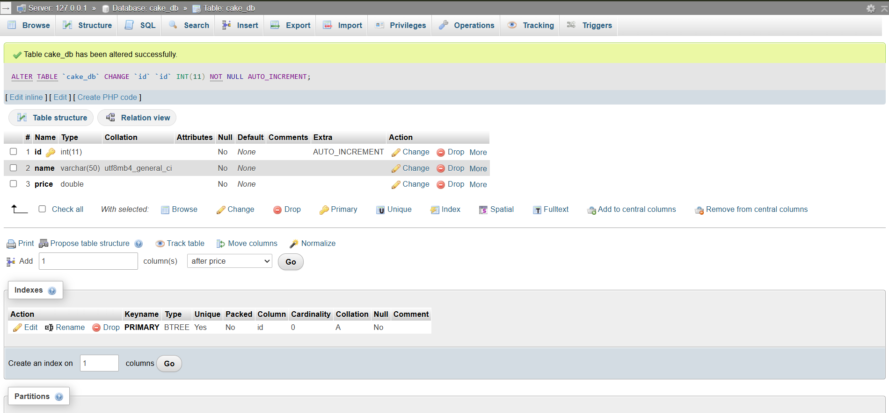
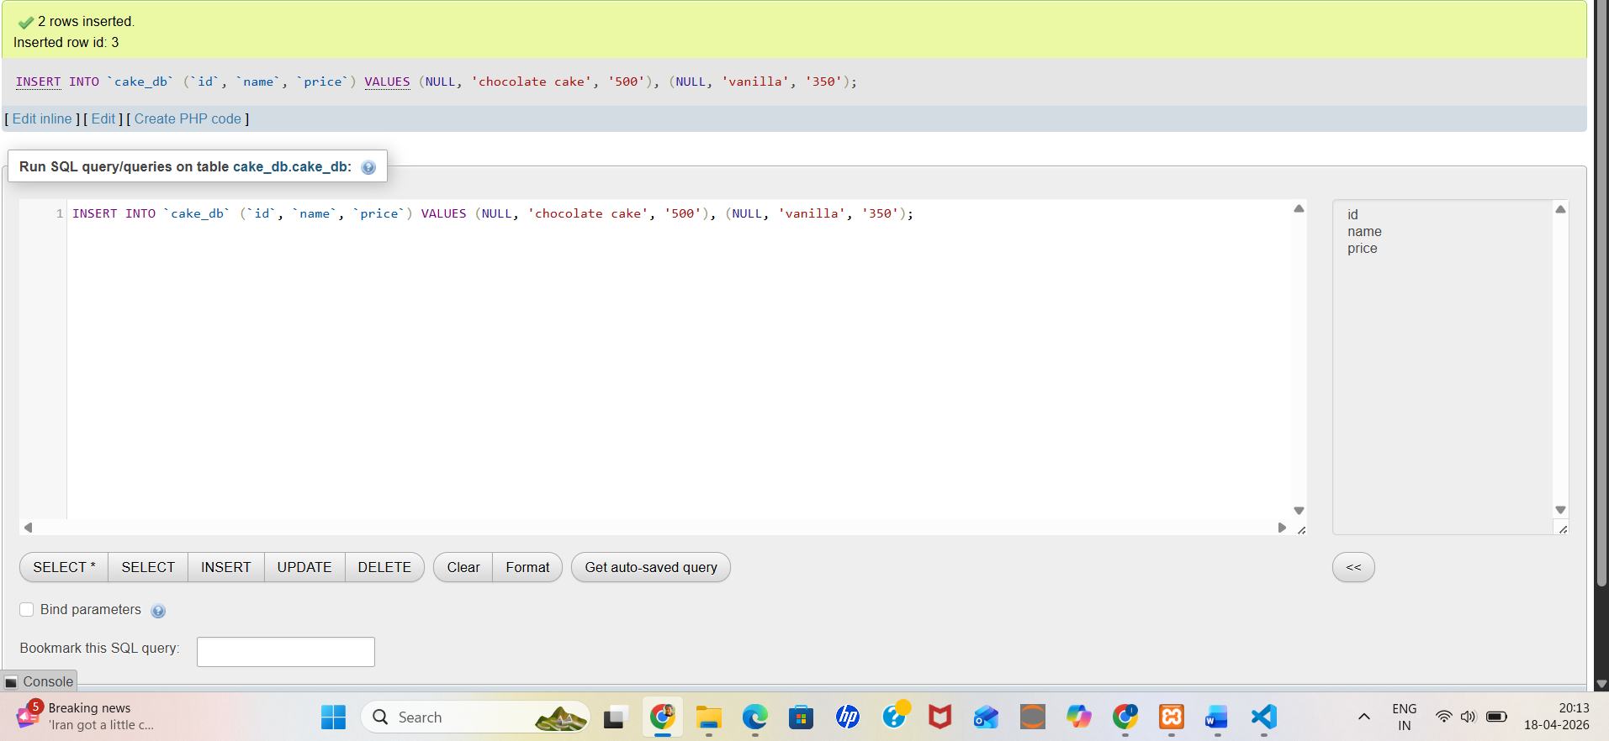
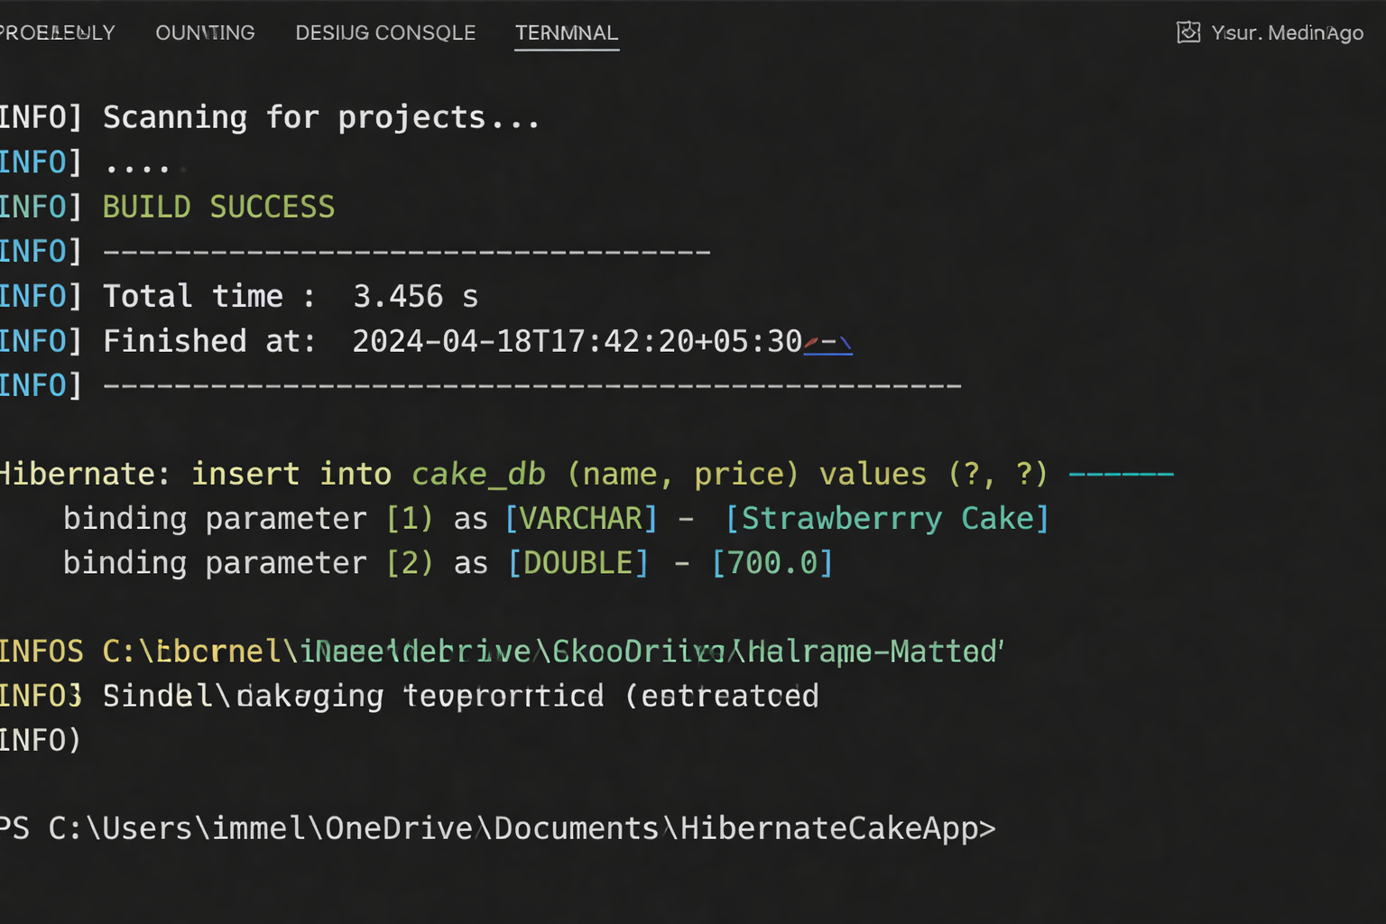

//Spring Standalone and web application

PROGRAM CODE:
Main Class
package com.example.demo;

import org.springframework.boot.SpringApplication;
import org.springframework.boot.autoconfigure.SpringBootApplication;

@SpringBootApplication
public class DemoApplication {
public static void main(String[] args) {
SpringApplication.run(DemoApplication.class, args);
}
}
MessageService.java
package com.example.demo.service;

import org.springframework.stereotype.Service;

@Service
public class MessageService {

public String bakeCake() {
return "Step 1: Mixing flour, sugar, eggs...\n" +
"Step 2: Pouring batter into pan...\n" +
"Step 3: Baking cake in oven...\n" +
"Cake is ready! Enjoy your cake!";
}
}

MessageController.java

package com.example.demo.controller;

import com.example.demo.service.MessageService;
import org.springframework.beans.factory.annotation.Autowired;
import org.springframework.stereotype.Controller;
import org.springframework.ui.Model;
import org.springframework.web.bind.annotation.GetMapping;

@Controller
public class MessageController {

@Autowired
MessageService service;

@GetMapping("/")
public String home(Model model) {
model.addAttribute("steps", service.bakeCake());
return "index";
}
}
pom.xml

<project xmlns="http://maven.apache.org/POM/4.0.0">
<modelVersion>4.0.0</modelVersion>

<groupId>com.example</groupId>
<artifactId>spring-web-app</artifactId>
<version>1.0-SNAPSHOT</version>

<parent>
<groupId>org.springframework.boot</groupId>
<artifactId>spring-boot-starter-parent</artifactId>
<version>3.2.5</version>
</parent>

<dependencies>

<!-- Web -->
<dependency>
<groupId>org.springframework.boot</groupId>
<artifactId>spring-boot-starter-web</artifactId>
</dependency>

<!-- HTML -->
<dependency>
<groupId>org.springframework.boot</groupId>
<artifactId>spring-boot-starter-thymeleaf</artifactId>
</dependency>

</dependencies>

<build>
<plugins>
<plugin>
<groupId>org.springframework.boot</groupId>
<artifactId>spring-boot-maven-plugin</artifactId>
</plugin>
</plugins>
</build>

</project>

Webpage:

<!DOCTYPE html>
<html>
<head>
<title>Cake Application</title>
</head>
<body>

<h1>🍰 Cake Baking Process</h1>

<pre th:text="${steps}"></pre>

</body>
</html>
Output:
